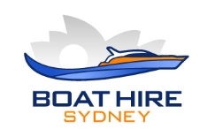

Zodiac Drinks Menu 2019-2020

Drinks Options
Sports Package:
A mix of soft drinks, diet drinks, water & ice
4 hour event$12 pp
5-6 hour event $18 pp

Captains Package
Includes the Sports package
plus beers & white wine & sparkling
Peroni, Corona beers, Oyster Bay sav-blanc
4 hour event $48 pp 5-6 hour event $60 pp

Admirals Package
Includes the Captains package
plus sparking and red wines
4 hour event $55 pp 5-6 hour event $70 pp

Individual Selection if no package
Ice (recommended) 5 kg bag $ 6
Mixed case of soft drinks and still water (24) $55
Case of still water (24) $50
2L orange juice $ 8
1L Cranberry juice $ 8
375ml cans of Coke, diet coke, lemonade or solo $ 3
600ml still water $ 3

